**1.2 KNOWLEDGE GRAPHS & RDF**

From web of documents to web of data

Data management for AI

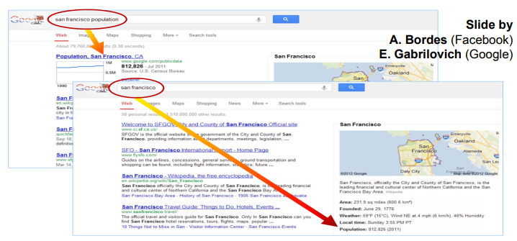

When people are searching online they are looking for some informations

We need to understand content

**What are knowledge graph**

When searching online looking for specific entities, like the population of a specific city.

There are many entities.

One crucial challenge. Understanding content, try to understand what we are referring about

Factual information: displayed in a way that we can understand. Can be true or false.

Fact: something that can be or not true.

We need to store entities somehow using DB or graphs. Graph can be process efficiently

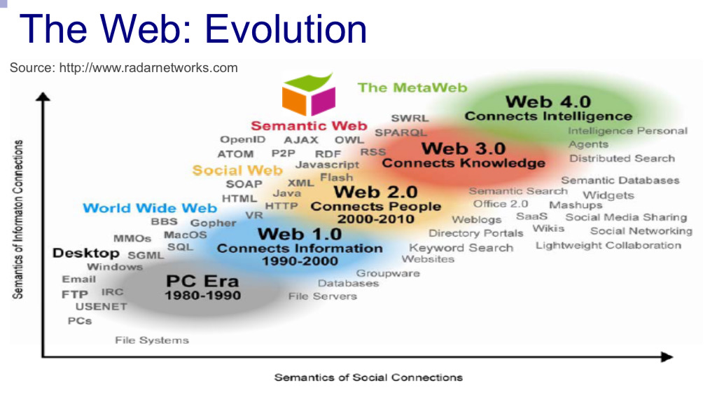

Evolution of web technology:

PC era

Web 1.0 in the web there were just documents and we develop technology to search in those documents

Web 2.0 Social interaction and social interactions appear

Web 3.0 - 4.0 where truth the web we exchange information and speak about knowledge and real word entities. Migration from the web of documents to the web of data.

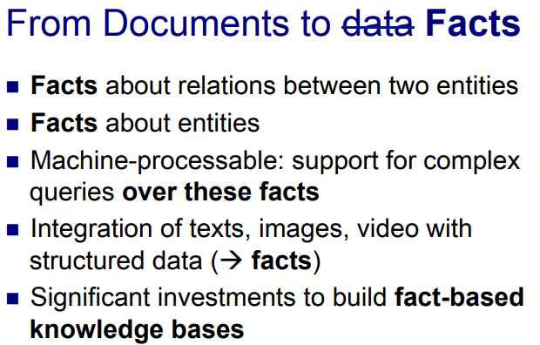

Transition from web of documents and facts. **Facts are about a relationship between two entities, facts describe those entities**.

Want to represent fact in a way that is under stable by human and processable by machine in a form that is convenient.

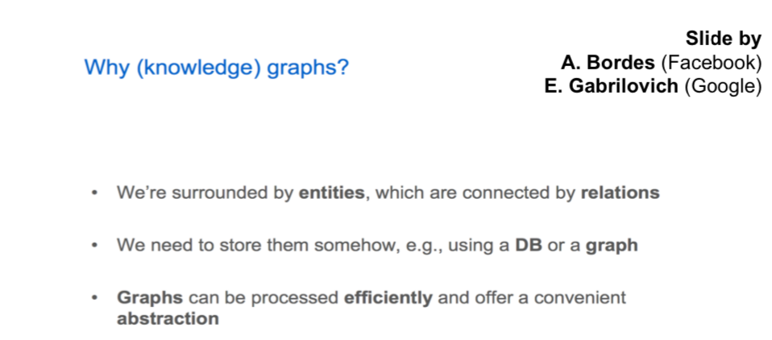

The idea of Knowledge graph we organise information that entities are first class citizens of this infrastructure.

In relational databases (one of the most used theology to store data) the representation primitive are relation. Relations can be viewed as tables.

We need to store using DB (data base) or graph. Graphs are quite easy and more convenient abstractions. We want to model entities and mutual relation

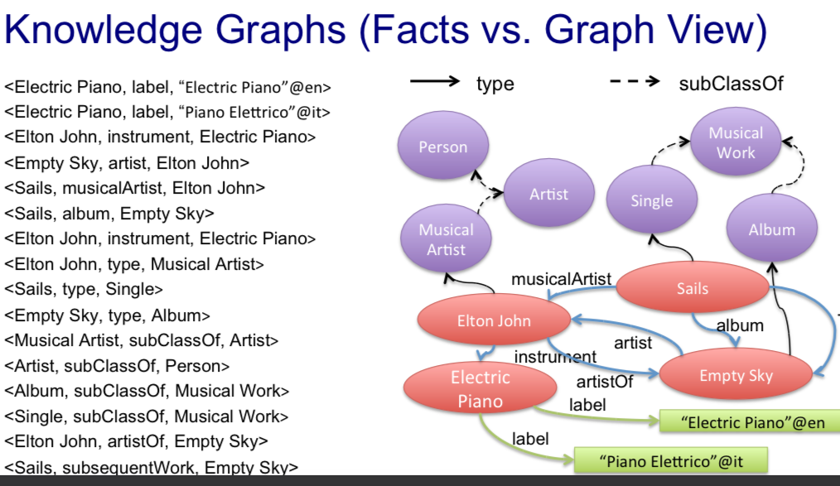

Each of these bullet is an entity

Fact base view on left

Graph view on right. Colors have a meaning (see later)

Each edge has a label. We can have multiple relationship

Fact base are labels, ordered sible of three elements

<Elton John, instrument, Electric Piano>

<Empty Sky, artist, Elton John>

<Sails, musicalArtist, Elton John>

<Elton John, artistOf, Empty Sky>

Are statement,

The graph are made by the first and third element

The second element represent the relationship (label of edges)

The graph view in another way to look as a set of statements

With graphs, we can understand knowledge. Also we can complete graphs, some algorithm search to complete knowledge or to find implications).

Also we can traverse those graphs. We can search if there is a path connecting different entities.

Graph and fact are about useful but in different ways

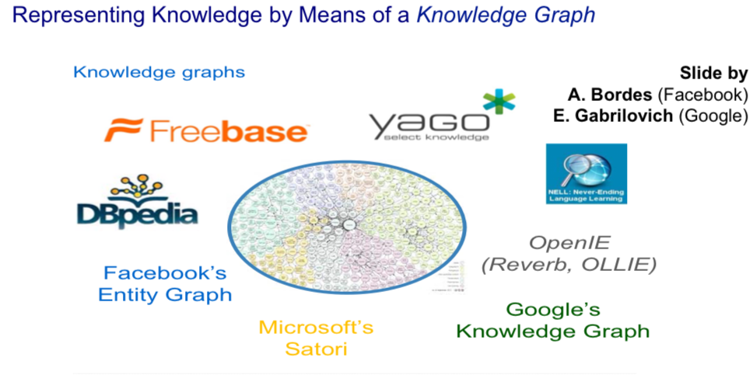

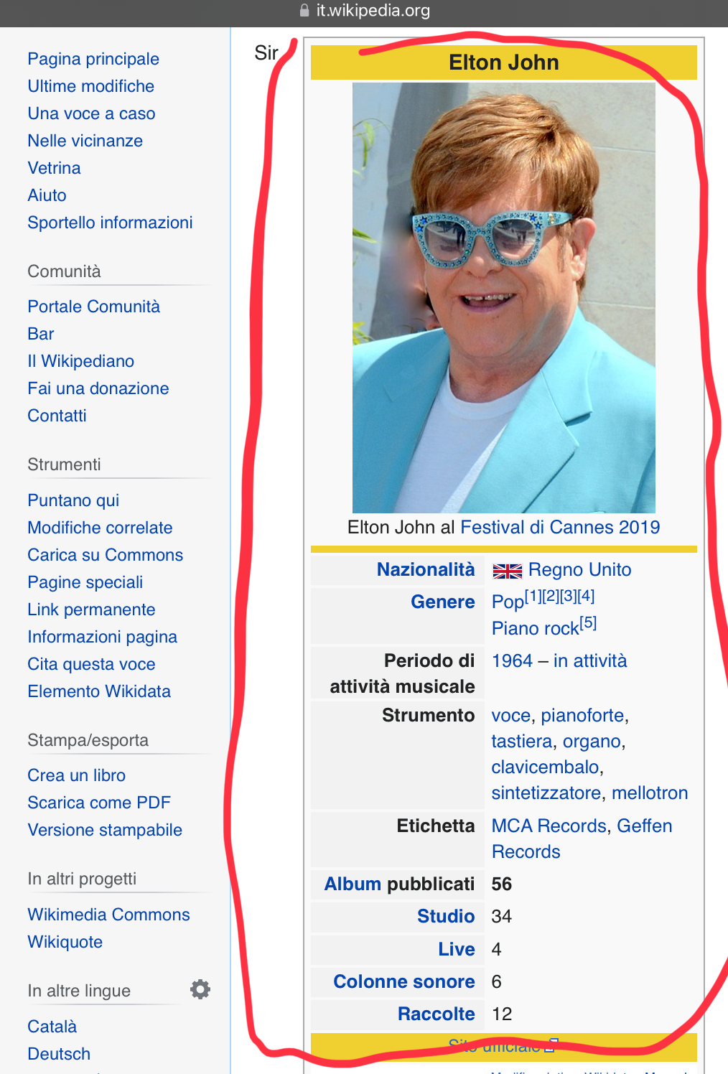

Infobox: most pages (the most important one) have an infobox.

Knowledge bases refert to re positive of informations

DBpedia is a knowledge graph that represents structural information in Wikipedia.

Searching for *Elton john*

Info box

People edit files in Wikipedia. There are some policies, some templates are recomanentend

Wikipedia has produce a huge amount of encyclopedic knowledge available in many different languages, is a crucial sources for AI

DBpedia is a graph version of Wikipedia, created by extracting information from the info boxes, extracting knowledge and organizing it in a graph form.

Freebase: similar idea of Wikipedia but for data. Acquired by google.

WIKIDATA European effort doing what freebase is doing in the USA. Algorithms edit the information. Becoming a very important project

DBpedia, Google Knowledge Graph… are all knowledge graphs that represent cross-domain encyclopedia knowledge. DBpedia Is one of the main results of semantic web build machine processable information that can be storage in the web.

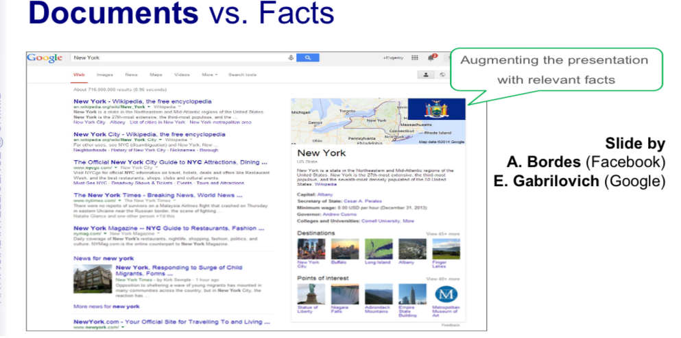

Add information, search information gives also the actors…

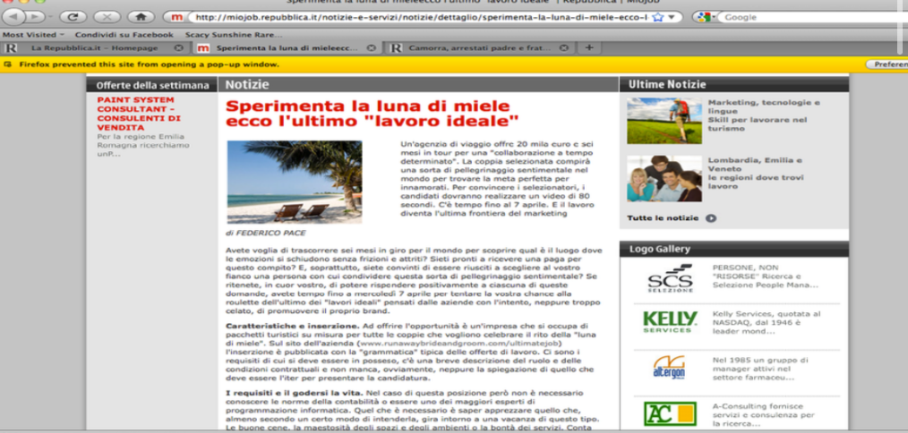

Images, videos, audio are unstructured data

We will focus on text. Text is unstructured because we are able to read.

If I have a text, a human can read and then answer questions related to the text. This is a signal that you understand the content.

But machine they got ability of answering question is improved, until a few years ago that was not possible.

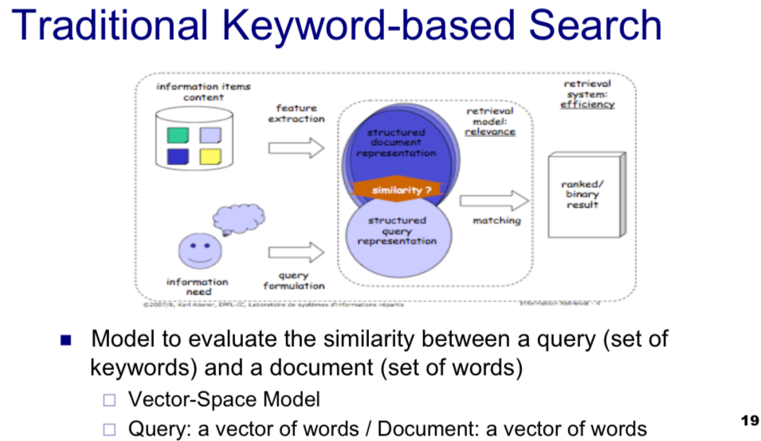

Using a mathematical model should be able to handle the estimation of data very very fast. Want results in milliseconds. But also Google has millions of documents

We respect the queries and documents as vectors.

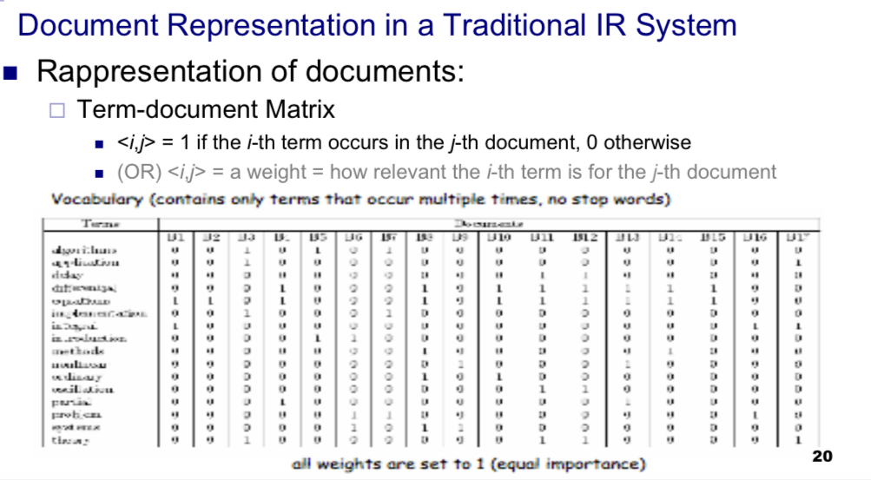

**Term-document matrix**

Documents on the columns

Terms on the left. Each word is a token.

1 if the term occurs in the document

0 if the term does not occur in the document

Not all the words have the same importance in a text.

Instead of using just 0 and 1 we put a weight (from 0 to 1) such that we calibrate how much is important each word is in a document.

We can use several scoring functions. TFITF term frequency / inverted term frequency

A term is more important in proportion to the frequency it has on that document. If on my document there is a lot of time the word *Justice* we know that *Justice* is important in that document.

Inverted term frequency: the importance of a term is inversely proportional to his frequency in his all collection.

As an example “*And”* it occurs a lot of time in a lot of document, so it is not much important in a document.

If *justice* does not appear in any other documents but just in one then is definitely important in that document.

There are also more sophisticated scheme (normalisation… and other complicated things)

People try to trick the system so that your result pop-up in the search. There are some way to fix this problem.

Many search engine apply a locality factor. Optimise the search result for that specific location (particularly true if searching in google maps)

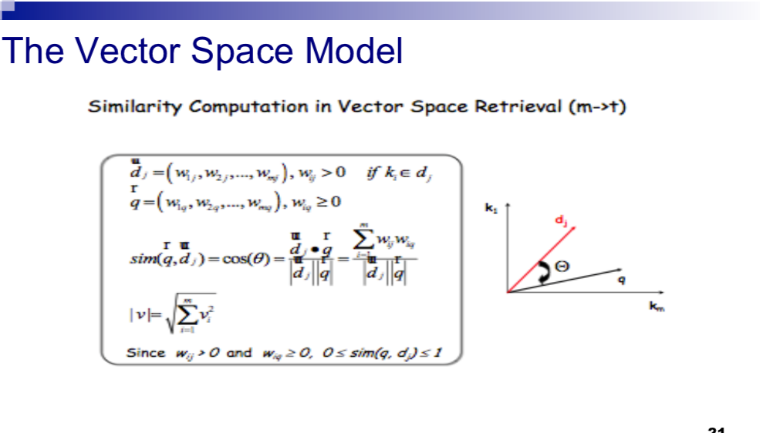

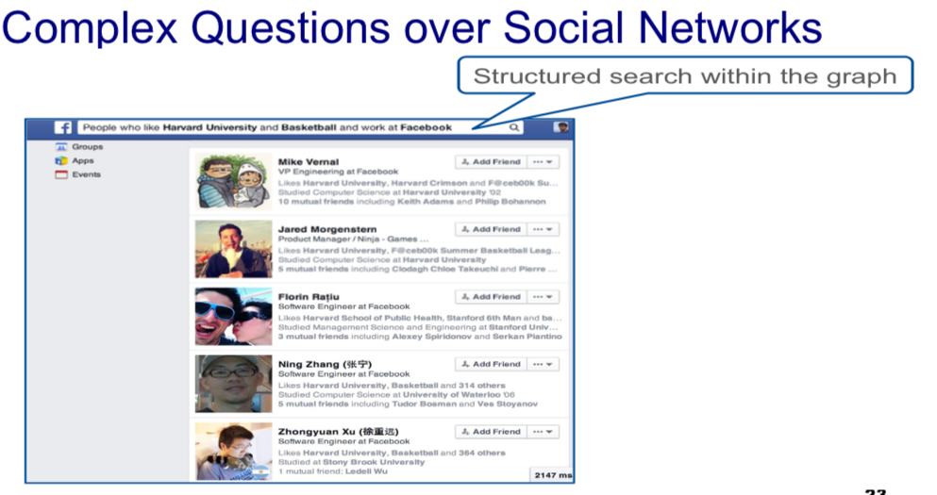

When we make a search it optimise the results. When we want a representation that support complex queries we mean like *people tha like Harvard university nd basketball and work at facebook.*

We don’t want to compute how similar is the description to the profile of the user. We want to find all the people that like an university and basketball and work at facebook.

Why Facebook interested in this queries? Doing this for targeting advertising. If you are sponsoring something you want to find the right target.

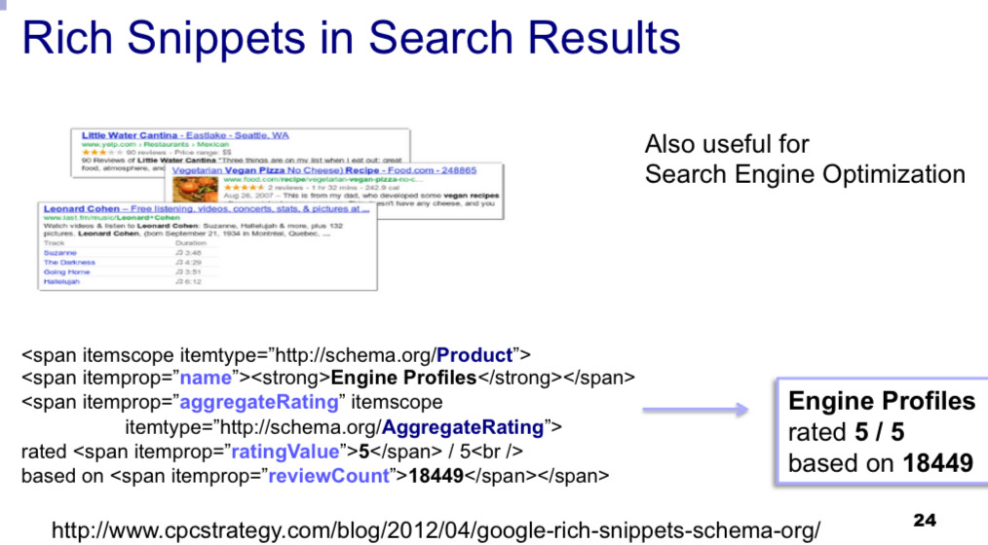

When you search n google something you find those kind of results, called *rich snippets*. Is not a document, is summaries informations (price, how many start…)

The idea is that you want that concept producer describes this content with structured approach

they summarise the information. You want the e-commerce (and so on) describes its content with some structure . Is not just pure text

If you have e-commerce you should earnarch your informations because you will increase the probability that people will click on your ad.approach

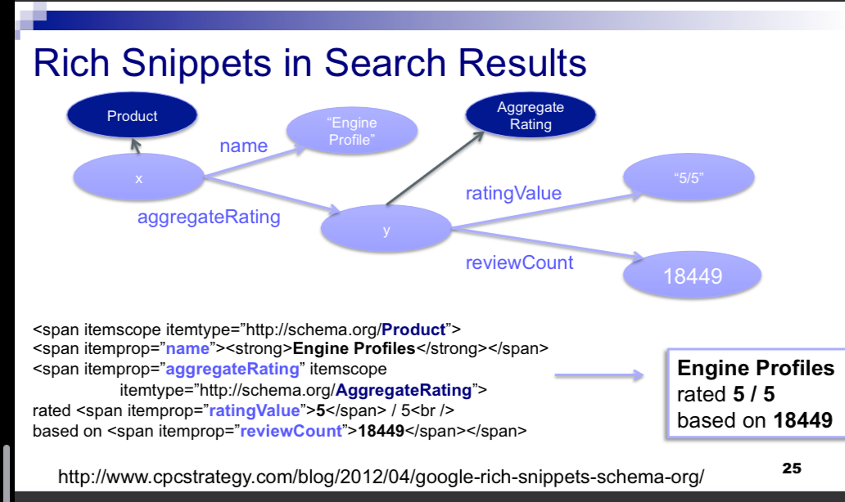

It has is graph

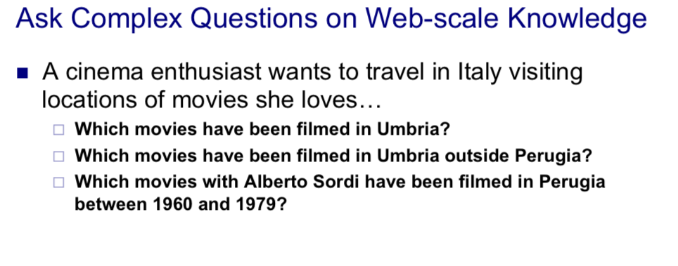

The target is a task is the 5th essential task for AI that is *question answering*. Want to build a system that you can post queries in natural language and can return an answer in natural language (if you have a conversational agent) or some results.

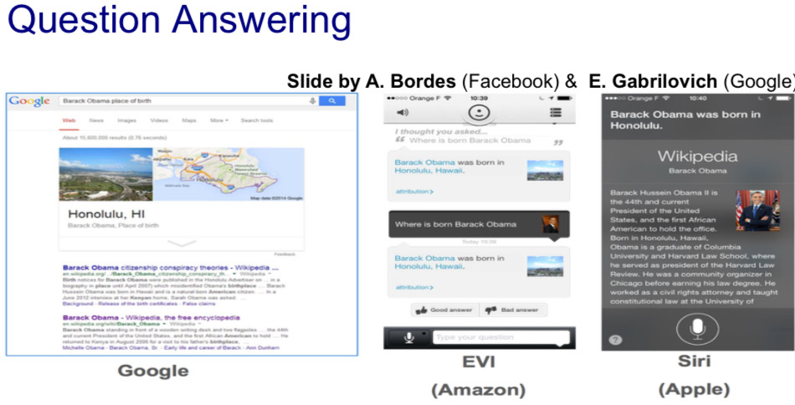

Not all the questions are process in that way

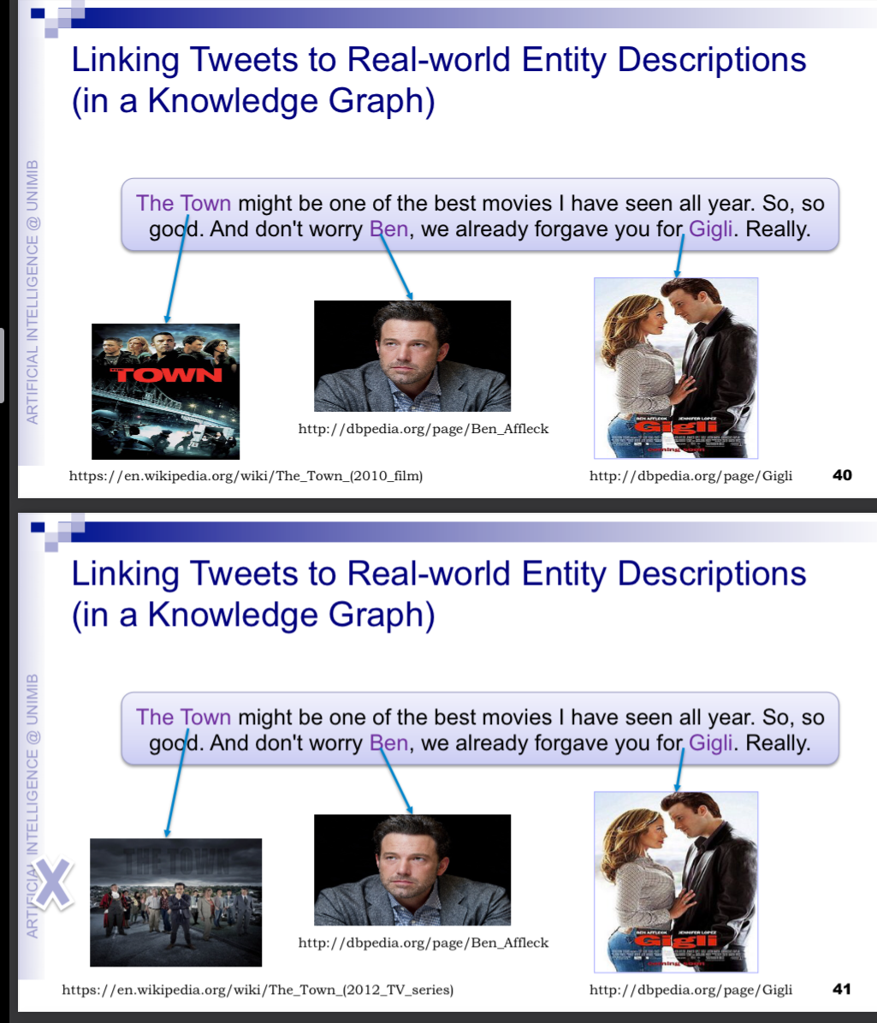

How do we know that the town is the movie and not the tv series? How can we disambiguate?

* popularity is a criteria to take in a consideration
* Context also is important
* Don’t trust the text too much. *Movie* might be refer to *ben* or *year*
* Time is also an interesting aspect. Popularity is related also to time

Knowledge graphs come to help, it represents the connection between *the town the movie* and Ben Affleck. In the knowledge graph we store this kind of connection

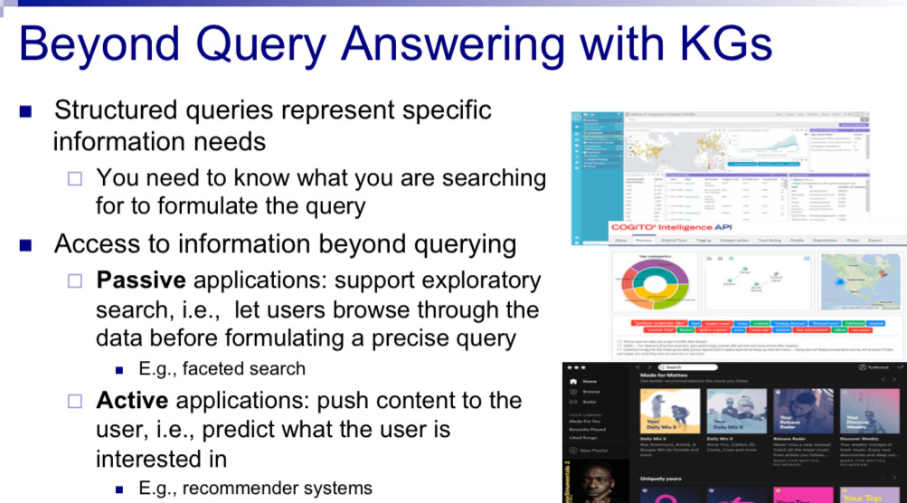

When you need to make a present you usually explore and search. Knowledge graph help us understand this

You build a system that has a goal to provide information to human decision make.

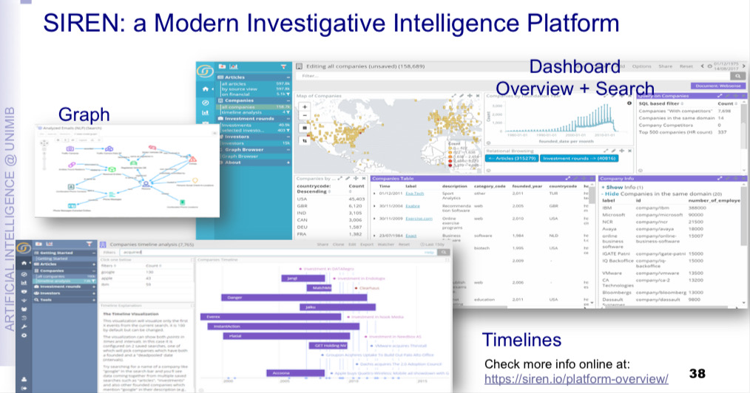

Knowledge graph stay behind

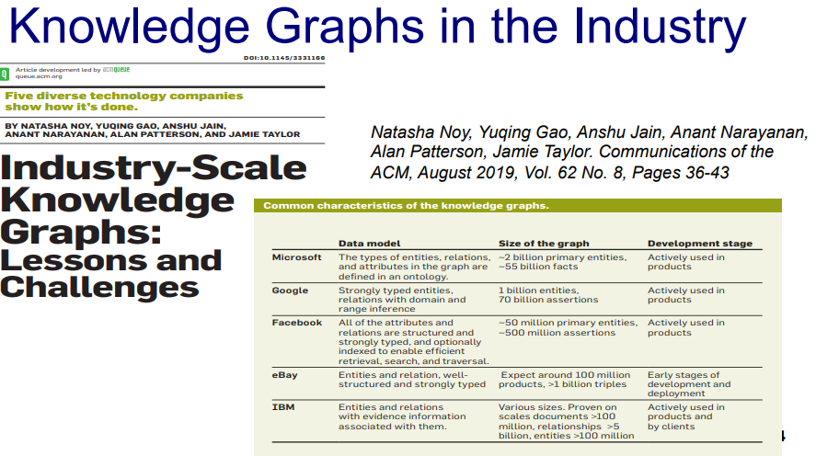

Goel has 1bl entities and 70billion assertions

The idea of connecting unstructured data to structure data to support several downstream applications is an idea that works also for photo, videos..

If you search on google photo, google extract people and it is up to you to link in.

**WHAT ARE KNOWLEDGE GRAPH**

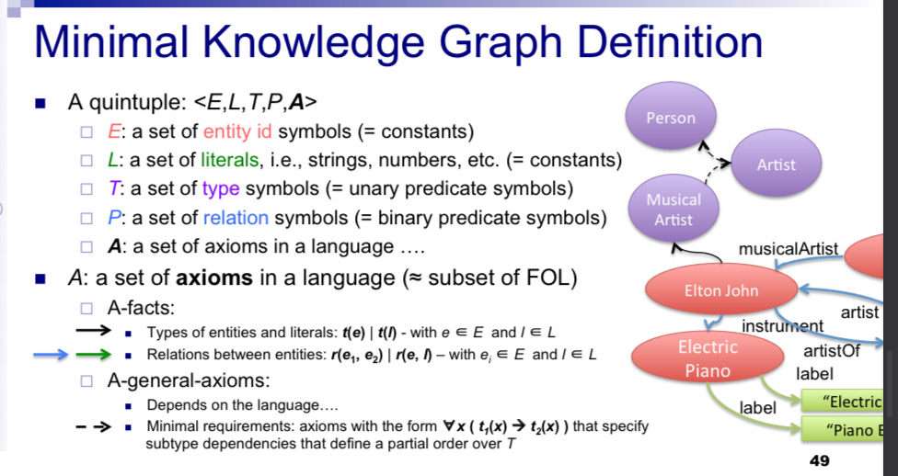

DL (description logic) are a subset of first order logic

5 element Tuples

E: in first order logic is equivalent to constant

L: from a logical point of view they are still constant but technically they need to be handle differently

T: refers to classes or concepts.

P: relation. In first order logic is equivalent to have binary predicate symbols

A: the language might change. Axion can be different depending on the language. There are two set of facts

* A facts: something that talks about specific entities or connects entities to types. The first type of fact is the link between entities or liters to their type. Can be interpreted as the formula where a unary predicate of a term and relation between entities
* A general axiom: depends on the language

To be a KGraph should have at least one relationship between types

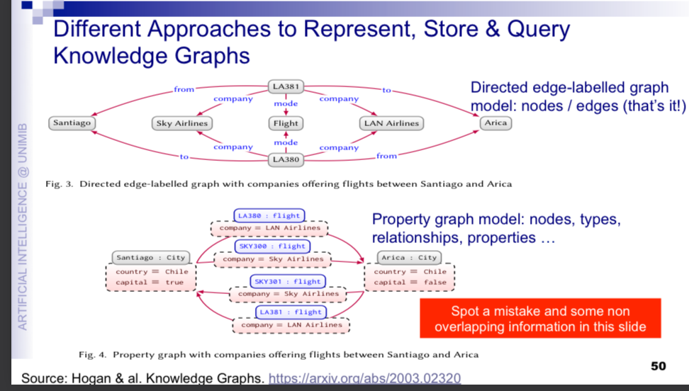

Directed edge-labeled graph model: only have nodes and edges

Another data management approach that is frequently use in the industry is the **property graph model** where there are nodes, types, relationship and properties

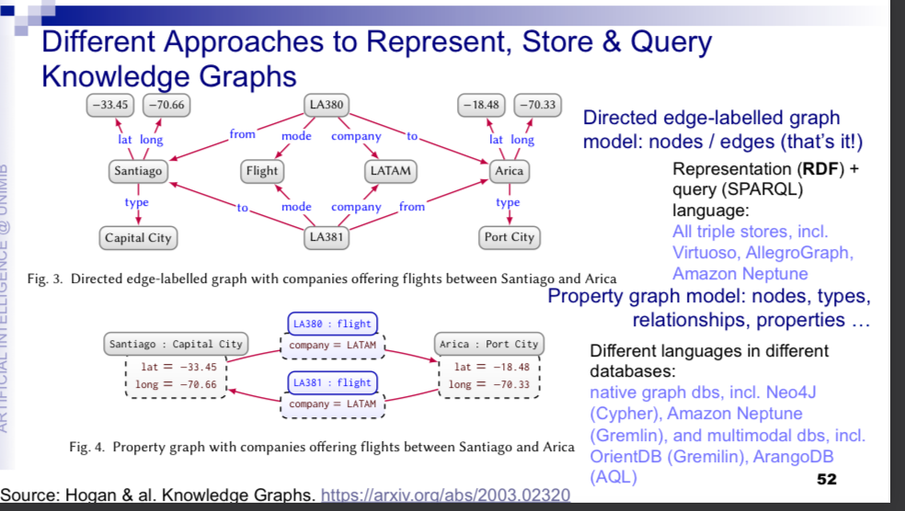

Typing is stric: declare the type of the node.

## RDF Resource Description Framework

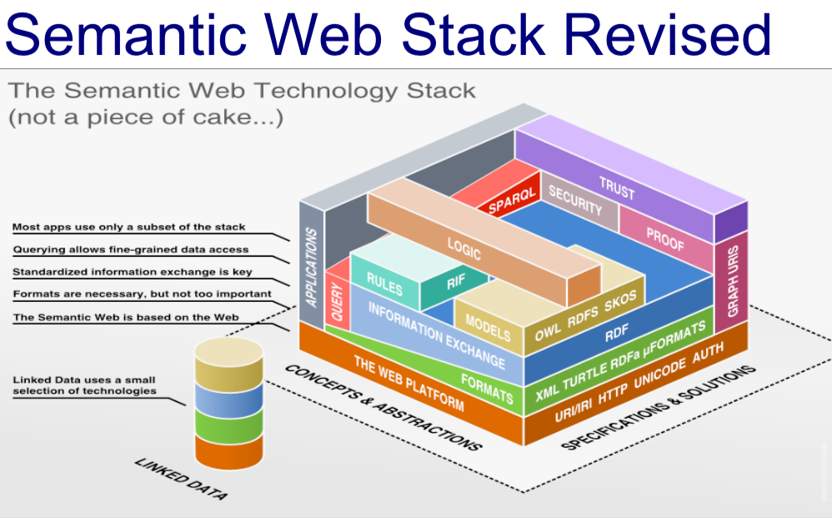

## What is RDF

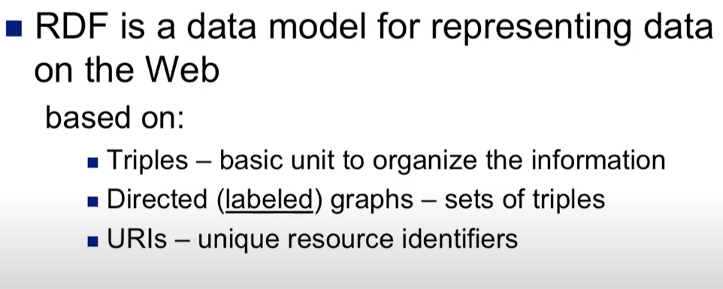

Data model to represent data based on 3 principles

* triples - basic unit to organise the information
* Directed (label) graph - set of triples
* URIs unique resource identifier. Identify those resources

### Triples:

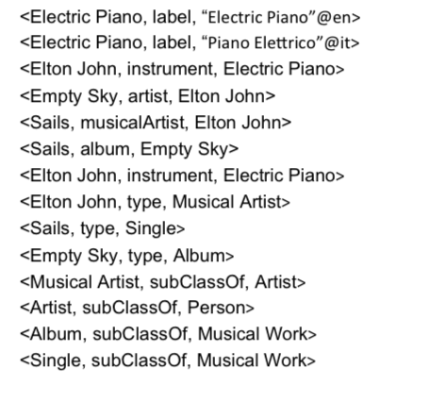

Those are triples ↑ also called *statements*

< subject, predicate, object >

### Directed (label) graph

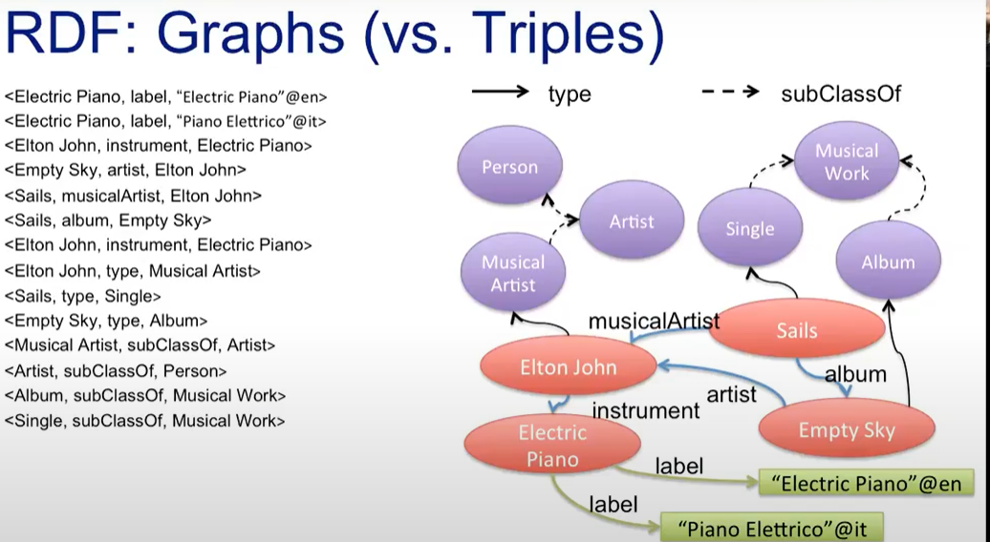

Direct label graph:

Everything that is in the subject and object position is a node in the graph

Everything that is in the predicate position is the label that we use in the edges

We can add any type as many triples as we want

### URI (Uniform Resource Identifier)

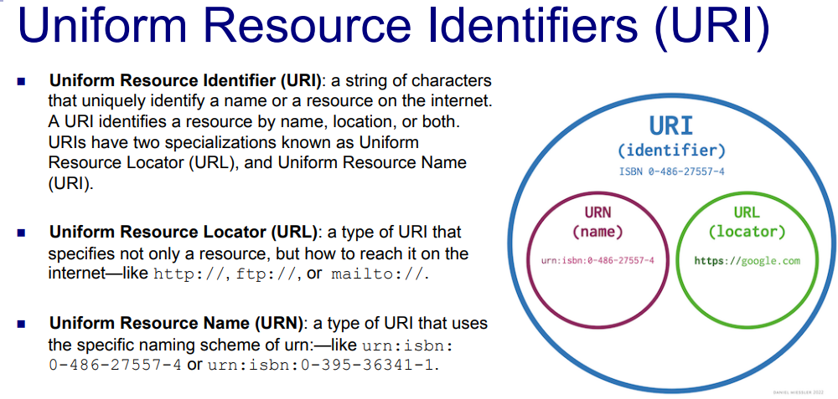

This mechanism is introduced to identify the resource on the internet-

There are different types of URI

* URL (Uniform resource Locator). Contain the address to get the resources
* URN (Uniform Resource Name). Use the specific naming scheme, is a global name, globally that has 1 intender interpretation

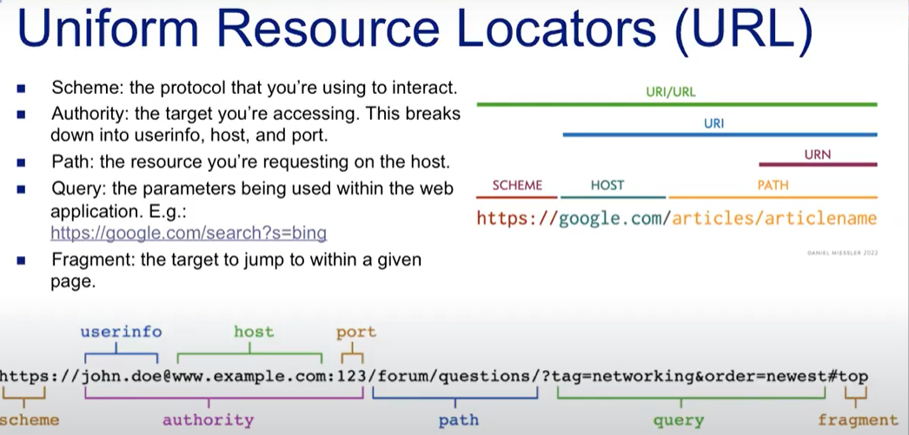

When you register a domain you register an autoritify: you own that domain.

You are naming one resource. One server is able to replay with that resource

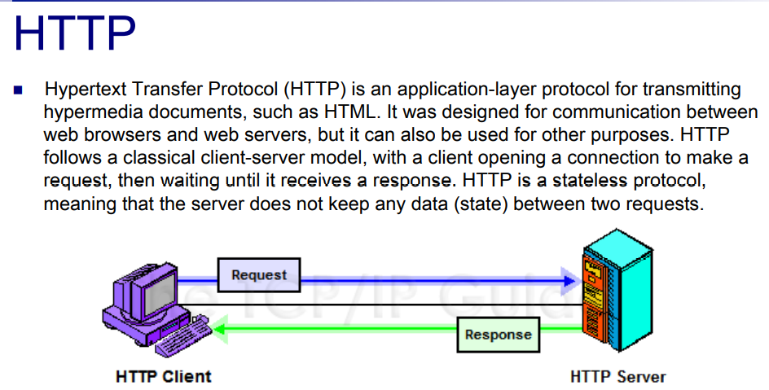

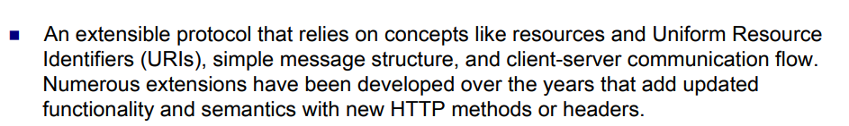

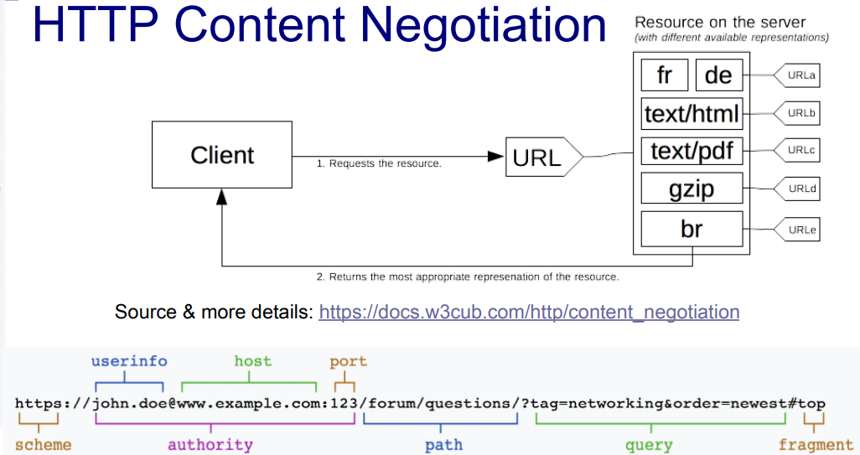

One resource can have different version

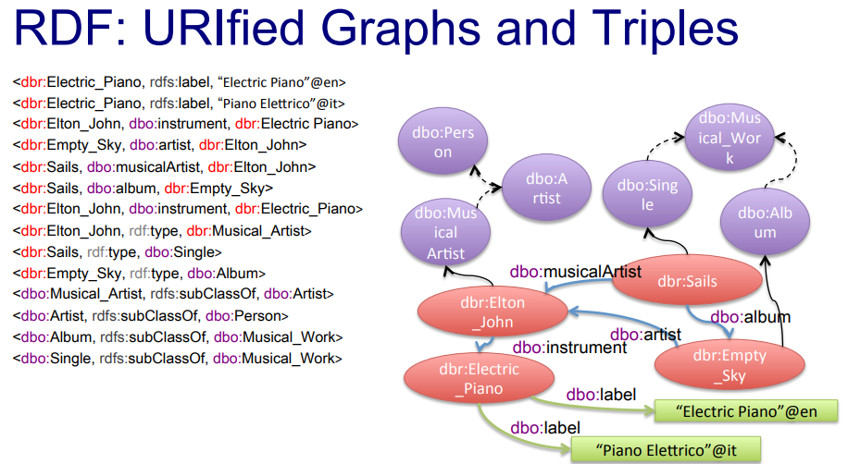

Instead of using constants you use name identifiers that are based on the URI mechanism.

Dbr: dbpedia resource

Most of the notes in this graph will be identified by the URI

<https://dbpedia.org/resource/Elton_John>

The roots know to ask to the DBpedia serve

Most of the notes are url. We have things that we don’t want to specify. In addition to resources we want to have ways to refer to data.

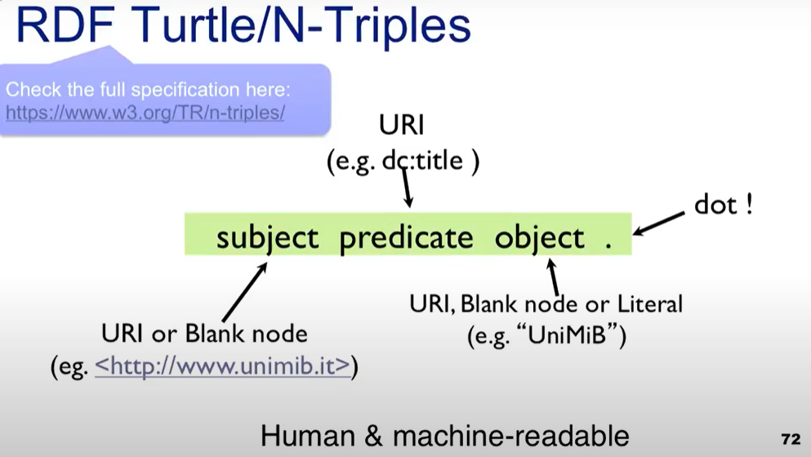

A triple: subject, predicate, object and finish with a dot.

Where

* The subject is a URI or a blank node
* The predicate must be an URI (we don’t accept pane text or numbers)
* Object: can be a URI, black node or literal

N-triples is a subset of turtle that uses these simple structure.

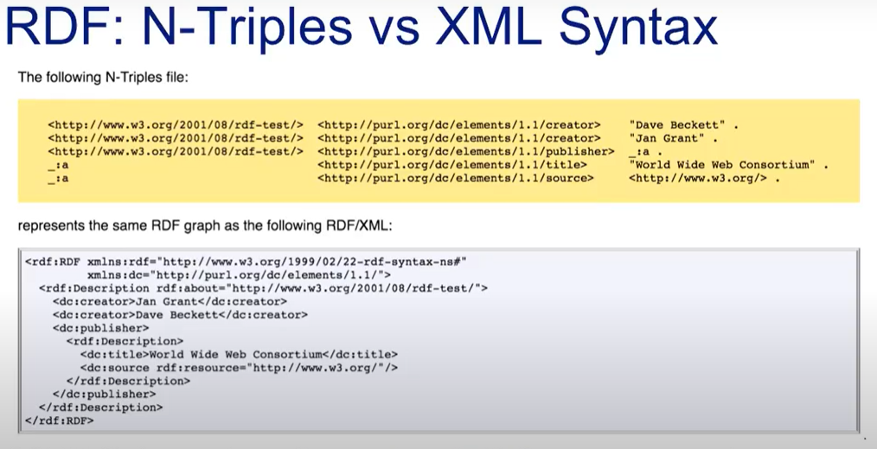

Literal: we use literals to refer to pieces of data that we don’t want to identify.

*2006* is a string or a number? It depends. By default everything that is not a type is a string

Black nodes: like local names, similar to a skolem variable

